Experiment No. 2(Group A)

Aim: Design a wireframe for an online learning platform that includes course listings, video lectures, quizzes, and progress tracking.

Outcome: At end of this experiment, student will be able to design a online learning platform using wireframe tool.

Software Requirement: IDE (e.g., Xcode or Android Studio), design tools (e.g., Figma or Adobe XD or Wireframe)

Theory :
Wireframing is an important tool for product design and development. Whether you’re building the next hot startup or a solid website or mobile application, wireframes are invaluable in keeping everyone on the same page – not just product managers, designers, and engineers. And they can be changed really quickly to accommodate the collaborative and iterative nature of product design and development, especially in agile startups and enterprises. For this reason, wireframes are typically created in the product design and development process in one way or another, even if it’s a quick sketch on scratch paper or a grid notepad.
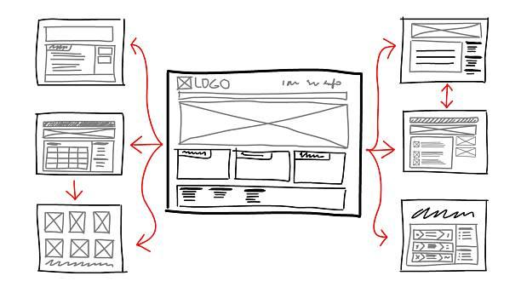

Wireframes are the “blueprint for design.”
They’re supposed to connect the underlying conceptual structure (or information architecture) to the surface (or visual design) of a website or mobile app. More specifically, they’re visual representations of an interface, used to communicate the following details to get everyone on the same page:
• Structure – How will the pieces of this site be put together?
• Content – What will be displayed on the site?
• Informational hierarchy – How is this information organized and displayed?
• Functionality – How will this interface work?
• Behavior – How does it interact with the user? And how does it behave?
In wireframing, "high-fidelity" and "low-fidelity" refer to two different levels of detail and complexity in the wireframe design. These distinctions are important because they serve different purposes in the design and development process:
1. Low-Fidelity (Low-Fi) Wireframes:
- Simplicity: Low-fidelity wireframes are basic and minimalist in nature. They use simple shapes, lines, and placeholders to represent page elements such as text, images, buttons, and navigation menus.
- Purpose: Low-fi wireframes are primarily used for early-stage ideation and concept development. They help convey the overall layout and structure of a webpage or application without getting into specific design details.
- Speed: They are quick to create and easy to modify, making them ideal for brainstorming and rapid iterations. Changes can be made without investing much time or effort.
- Feedback Focus: Low-fi wireframes are often used to gather feedback on the general information architecture, page flow, and content placement rather than visual aesthetics.
2. High-Fidelity (High-Fi) Wireframes
- Detail: High-fidelity wireframes are more detailed and polished. They include finer design elements, such as specific fonts, colors, and visual styles, to closely resemble the final product's appearance.
- Purpose: High-fi wireframes are created in later stages of the design process when the overall layout and structure have been finalized. They serve as a bridge between wireframes and full-fledged visual design, providing a clearer representation of the final user interface.
- Realism: High-fi wireframes can convey a more realistic impression of what the final product will look like. They help stakeholders and designers better understand the visual aspect of the design.

-Development Reference: Developers often use high-fi wireframes as a reference when building the actual product because they include more detailed information about design elements and interactions.

Conclusion:

